MAP1_14 quick reference

Ray Meddis, University of Essex, Colchester, UK CO7 9SW.

Email: rmeddis@essex.ac.uk.
Update 27 May 2011

MAP1_14.m is a simple and fast version of the MAP model. It is a single function that includes all stages of the auditory periphery. MAP1_14 has full efferent functionality; both acoustic reflex and MOC efferent functions are automatically enabled.

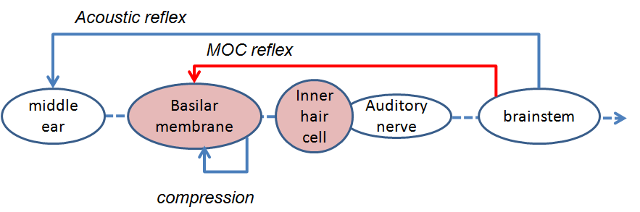
Figure 1
Schematic of the auditory pathway modelled by MAP1_14.

Folder structure
The model is contained in a function called MAP1_14.m. This function can be found in MAP1_14*\MAP. The ‘*’ allows for version changes within the MAP1_14 series.
Other folders within MAP1_14* include parameterStore, utilities, wavFileStore and testPrograms. Another folder is called ‘multithreshold 1.46’. This contains psychometric testing software which can be harnessed to the MAP model.
Note: the modules folder to be found in earlier versions of MAP no longer exists as the program is no longer modular

test_MAP1_14.m
To get started, you can use the simple test programs in the testPrograms folder. Two programs ‘demoTwisterProbability’ and ‘demoTwisterSpikes’ both take the acoustic input from a .wav file called ‘twister_44kHz.wav’ and process it through the model.

demoTwisterProbability
The first program (demoTwisterProbability) plots the auditory nerve (AN) high-spont (HSR) and low-spont (LSR) response in 21 channels with BFs between 250 Hz and 8 kHz . It also plots the output of the three previous stages (stimulus, stapes and BM). This is shown Fig. #A. The AN response probability plot is a little crude because it is generated by the high-speed function imagesc. A second image (Fig. #B) is generated showing the high-spont fiber response as a surface plot which is smoother and more informative. For some long acoustic files, this might prove to be inconveniently slow however.
The output of the two programs looks something like this. Warning: When you run the program, the figure you obtain may differ in detail from the pictures shown here. Changes to the parameter files will have this effect and these pictures do not always get updated when the standard parameter file is changed.
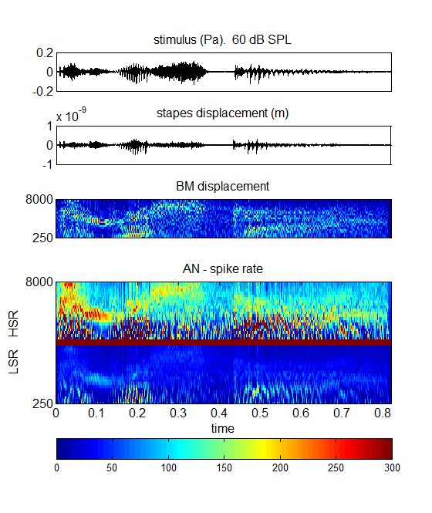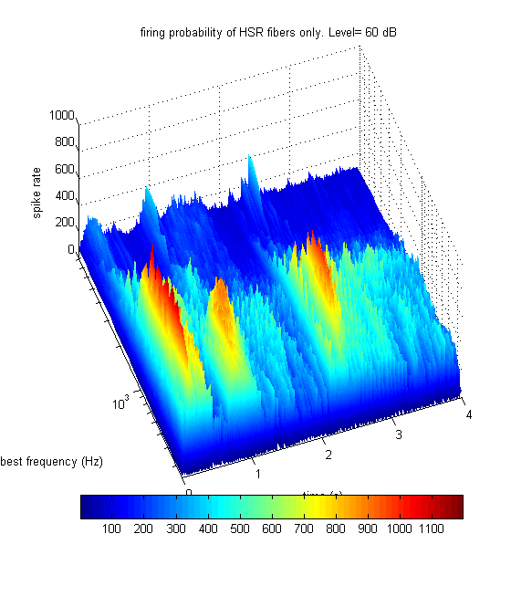
Figure 2
A: Model output for the demonstration file demoTwisterProbability. The input utterance is the word ‘twister’ spoken at an rms level of 60 dB SPL by a male speaker. The model has 21 channels with BFs between 250 and 8000 Hz (evenly spaced on a logarithmic scale). The top three panels represent the signal, stapes displacement and basilar membrane displacements respectively. The bottom panel shows the AN response firing probability computed for both high and low spontaneous rate fibers in the upper and lower part of the panel respectively.
B: Surface plot of the high-spontaneous rate fiber response only. This is based on the same data as the upper half of the bottom pane to the left.

demoTwisterSpikes
The second program (demoTwisterSpikes) computes the AN response as actual spikes and then uses these spikes as the input to arrays of neurons in the cochlear nucleus and inferior colliculus. In both cases the cells are configured as simple chopper cells. This may not interest many users who will be content with a simulation of the auditory nerve response. The response of brainstem neurons to acoustic stimulation is at the cutting edge of auditory modelling and this example is included here to illustrate the possibilities of this kind of modelling. This model is, in fact two models; one using high spontaneous rate (HSR) AN fibers and the other using low spontaneous rate (LSR) AN fibers.
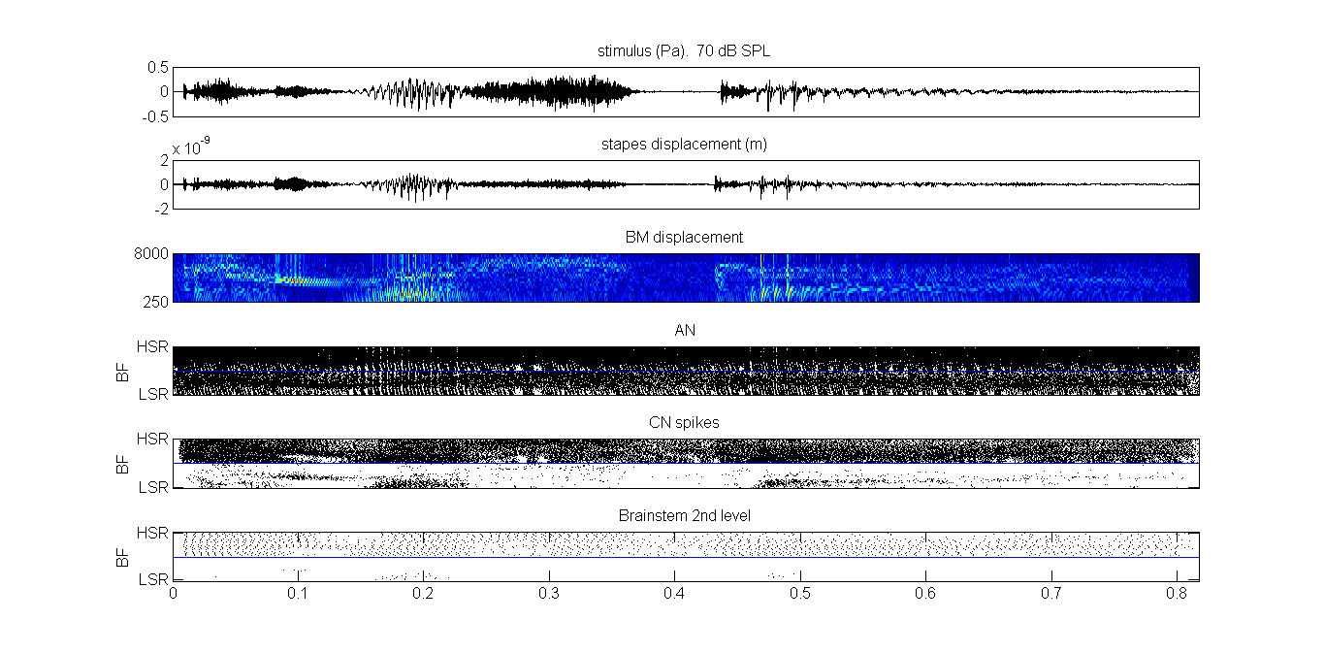
Figure 3
Model response to the utterance ‘twister’. The first three panels are the same as the previous figure. The auditory nerve response (panel 4) is given as a raster plot of actual spike activity in 21 channels for two types of fiber; HSR (top of the matrix) and LSR (bottom of the matrix). There are 10 fibers of each type in each channel (making 420 raster plots). The bottom two panels show the spiking activity of simulated chopper units in two successive layers intended to represent some of the activity to be found in the ventral cochlear nucleus and the central nucleus of the inferior colliculus respectively. Again, the activity is separated into two independent sets depending whether it is driven by HSR or LSR AN fibers. Note that the LSR driven activity in the CN is small and in the IC it is absent. In this model, the activity of the LSR-driven activity is used to control the acoustic reflex at levels above 70 dB SPL. As a result this should not really be called IC activity but thought of as some other second-order neuron in the brainstem.

Model architecture
The model used has the architecture in Fig. #. Notice the feedback loops simulating the MOC efferent effect and the acoustic reflex. In this diagram the control pathways have their origin in the activity of the second-order brainstem neurons. If these are not computed (see the demoTwisterProbability example above) the efferent control path activity is inferred directly from AN activity. This is, of course, a short-cut to save time but the two models have similar properties..
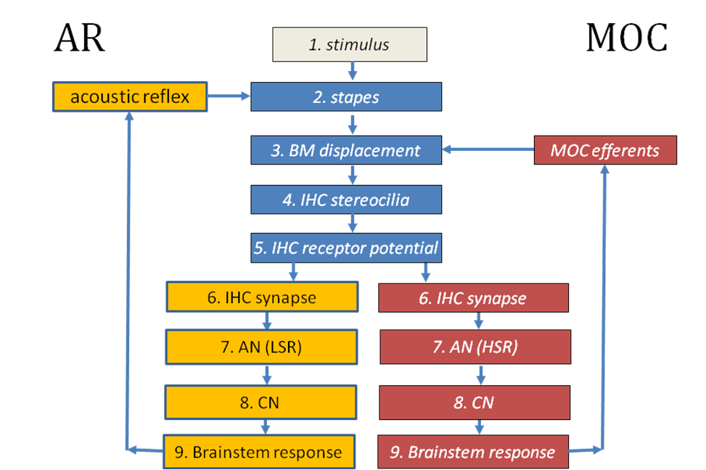
Figure 4
Flow diagram of the model implemented in MAP1_14*.

test_MAP1_14
‘test_MAP1_14’ (in the testPrograms folder) is a general purpose testing program that can be used to explore MAP1_14 more thoroughly. This program offers various options. Hopefully, these should be self-explanatory as you read through the program.
Basically, this code generates an acoustic stimulus and presents it to the model. The stimulus can be pure tones or the input from a wav file. The level of the signal (rms) can also be set. Options allow the user to define some of the details of the model. You will need to do this in the model code. This is intended to be an introduction to programming with the model.
If the following options are selected by default in test_MAP1_14:
MAPparamsName='Normal';
AN_spikesOrProbability='probability';
signalType= 'file';
fileName='twister_44kHz';
leveldBSPL= 70; % dB SPL
numChannels=21;
lowestBF=250; highestBF= 8000;
paramChanges=[ ];

You should get an output that looks something like the figure immediately below. This is basically the same as the figure above but it generates a third figure showing how the efferent functions have been activated. In this example (using a 70 dB speech signal) the AR reflex is not activated and the MOC reflex (which operates on a channel by channel basis) is moderately activated.
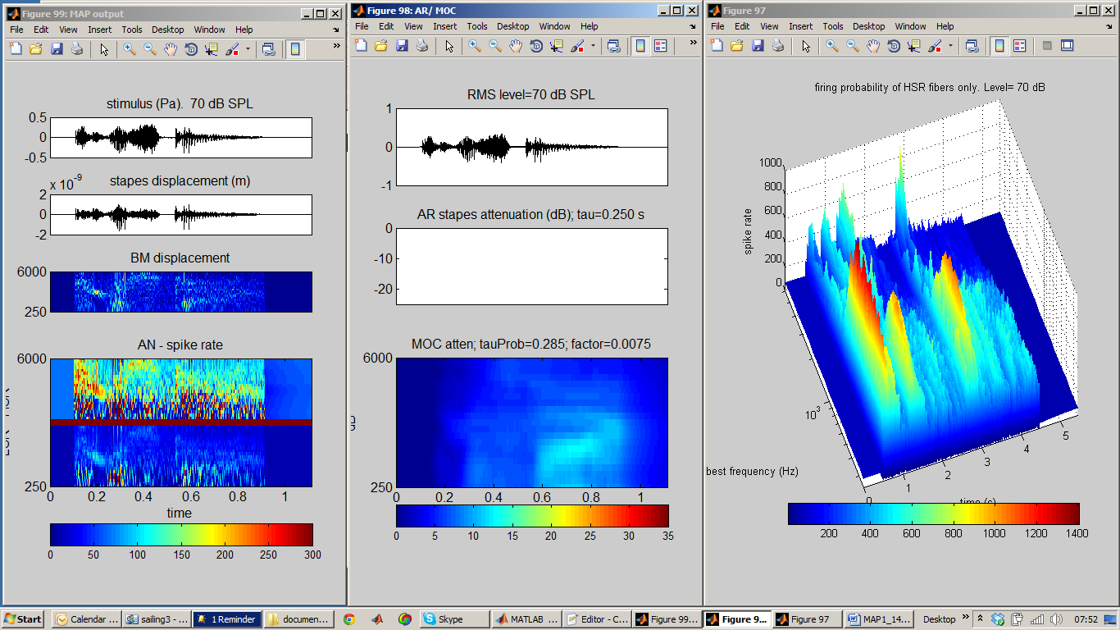
Figure 5

MAP1_14.m
MAP1_14.m is a single program file containing all instructions for executing the model and it is located in the MAP subfolder. Test_MAP1_14 works by calling this function..
The function call is
MAP1_14 (inputSignal, sampleRate, BFlist, MAPparamsName, AN_spikesOrProbability, paramChanges)
inputSignal is a single row vector in Pascals. (It is a row vector because the model code always regards the x-axis of a matrix as the time axis.) It is single row because the model only processes mono signals.
sampleRate is the inputSignal sample Rate (Hz)
BFlist is a vector of BFs (in Hz). If this is specified as ‘-1’, the list of BFs is based on the default values specified in a parameter file (see immediately below).
MAPparamsName e.g. ‘Normal’, is a string used to make up the name of parameter file (e.g. ‘MAPparamsNormal’). The parameter file contains all of the parameters of the model. Parameter files are always located in the folder called parameterStore.
AN_spikesOrProbability
=’spikes’ for full model generating individual spikes in AN as well as models of brainstem neurons.
=’probability’ for AN model based on spike probabilities. This option computes very much faster that the alternative ‘spikes’ option.
paramChanges is a cell array of strings containing commands to make last-minute changes to the model parameters after loading them from the MAPparams<*> file. This argument is optional. Calling programs can use this facility to explore the effect of parameter changes without disturbing the original parameter file. For example,
{'DRNLParams.a=0;', ‘DRNLParams.g=200’;}
This example sets DRNLParams.a to zero (effectively , disabling the nonlinear path in the DRNL model of BM response) while setting the gain of the linear path. These parameter changes overrule whatever is to be found in the MAPparams*.m function. To set up a string, copy it from the parameter file, add single quote marks.
Normally MAP1_14 will be called from another program that creates the input signal and analyses or simply displays the output. Look at the demo programs described above for examples of how this is done.

Outputs
The MAP1_14 function draws no pictures nor does it return any output directly. All results are stored in global variables. The most commonly required result will be the matrix ANprobRateOutput which is a BFlist x time matrix of estimated spiking rates using probabilities. The time axis (columns) is sampled at the sampleRate of the signal. ANprobRateOutput contains firing rates (spikes/s)
All values are international units (m, s, Pa, V, A)
The following global statement gives the calling program access to all important results
global dt ANdt savedBFlist saveAN_spikesOrProbability saveMAPparamsName...
savedInputSignal OMEextEarPressure TMoutput OMEoutput ARattenuation ...
DRNLoutput IHC_cilia_output IHCrestingCiliaCond IHCrestingV...
IHCoutput ANprobRateOutput ANoutput savePavailable ANtauCas ...
CNtauGk CNoutput ICoutput ICmembraneOutput ICfiberTypeRates ...
MOCattenuation

To explore these variables, run the demoTwisterSpikes or demoTwisterProbability scripts. Then in the command window execute the global statement above. All of the outputs should appear in your workspace.

Examples of output stored in global variables
The global variable savedBFlist hold the list of BFs used.
saveAN_spikesOrProbability indicates whether ‘spikes’ or ‘probability’ computations were requested.
saveMAPparamsName holds the name (in fact, part of the name) of the parameter file used.
If MAP1_14 is run in probability mode, the AN spike rate matrix (BF x time) can be found in ANprobRateOutput. If two fiber types are used (e.g. HSR and LSR), the top half of the matrix will be the output from one type of fiber and the bottom half from the other. By convention, the LSR fibers are located at the top of the matrix which is flipped in most plots to put the HSR at the top of the picture. The sampling interval for ANprobRateOutput is saved in the variable dt.
If MAP1_14 is run in spikes mode, the AN spiking output will be found in the matrix ANoutput. This is a logical matrix (0/1). The sampling interval is ANdt. The sampling rate is different (lower) for these computations because spikes are relatively sparse. Each row of this matrix is an individual fiber. The matrix is essentially a raster plot. Each BF is associated with many fibers (typically 100). All fibers with the same BF and fiber type are in adjacent rows. Fiber types are segregated with HSR fibers at the bottom of the matrix if more than one type has been requested. In most images/plots, the matrix is flipped to put HSR fibers at the top.
Output at each stage of the model is stored in the following variables:
- OMEextEarPressure acoustic pressure
- TMoutput tympanic membrane displacement (m)
- OMEoutput stapes displacement (m)
- DRNLoutput basilar membrane displacement (m) (BF x time)
- IHC_cilia_output IHC cilia displacement (m)
- IHCoutput IHC receptor potential (V)
The amount of efferent activity can be monitored using the variables ARattenuation (single row vector) and MOCattenuation (matrix BFs x time).

Program structure
MAP1_14 has two stages; the first 500 lines (or so) are used to allocate memory and perform all computations that need be done only once. The second stage computes the model, segment by segment, as quickly as possible.
The model is updated in short segments to allow for efferent feedback (AR and MOC) to be implemented. The segments are typically 10 ms long.

UTIL_showMAP.m
This is a general purpose function for reporting and plotting the output from the most recent MAP1_14 call. It assumes that all results are already present in global storage. It was used to generate the figures shown above. It is located in the utilities folder.
UTIL_showMAP.m is located in the utilities folder.
UTIL_showMAP (showMapOptions, paramChanges)
It reads all values in from global variables and assumes that MAP1_14 has recently been run, leaving all of its output in global store. It is able to generate a wide range of displays. These must be selected in the showMapOptions structure. The fields in this structure are all logical (true or false).
% showMapOptions.printModelParameters=1; % print model parameters
% showMapOptions.showModelOutput=1; % plot all stages output
% showMapOptions.printFiringRates=1; % mean activity at all stages
% showMapOptions.showACF=1; % SACF (probabilities only)
% showMapOptions.showEfferent=1; % plot of efferent activity
% showMapOptions.surfProbability=0; % HSR (probability) surf plot
% showMapOptions.fileName=[ ]; % parameter filename for plot title

The argument paramChanges is required to remind the system of changes currently applied to the parameter file. If this is omitted, UTIL_showMAP simply prints out what is in the original file. (This will be done automatically in future).

UTIL_showMAP is used by the demo files described above. Consult these scripts for examples of how to use it.

Physiology check-up
The test programs, testPhysiology and testPhysiologyProb, can be used to ‘exercise’ MAP to check that it is functioning correctly. To run it you will need to navigate to the test programs folder and type on the command line:
testPhysiology(1000, 'Normal', paramChanges)
testPhysiology(1000, 'Normal',)
testPhysiologyProb(1000, 'Normal', paramChanges)
testPhysiologyProb(1000, 'Normal')
This will evaluate MAP1_14 in a single-channel model with a best frequency of 1 kHz using the model parameters to be found in MAPparamsNormal but incorporating last-minute parameter changes specified in the final argument. If parameter changes are not required, the final argument can be omitted. testPhysiology runs the model in ‘spikes’ mode while testPhysiologyProb runs is in ‘probability’ mode and is faster.
The program measures the
- Stapes response at a range of frequencies
- BM I/O function, the MOC elicited by the stimuli and the iso-reponse contour (‘tuning curve) at a number of different response levels
- Various IHC I/O functions of which the most useful is the receptor potential (bottom right).

  - (testPhysiologyProb ) AN firing rate I/O function based on actual spikes (top right)
  - (testPhysiology) AN firing rate I/O function based on actual spikes (top right) also CN and IC I/O functions – one function for each of the fiber types selected.
- Synapse response (available transmitter) as a function of time and level
- (testPhysiology) Forward masking simulation of an experiment by Harris and Dallos
- (testPhysiology) AN phase locking assessment based on an experiment by Johnson
The output from the function should look like this (details may vary).
testPhysiology(1000, 'Normal', paramChanges)
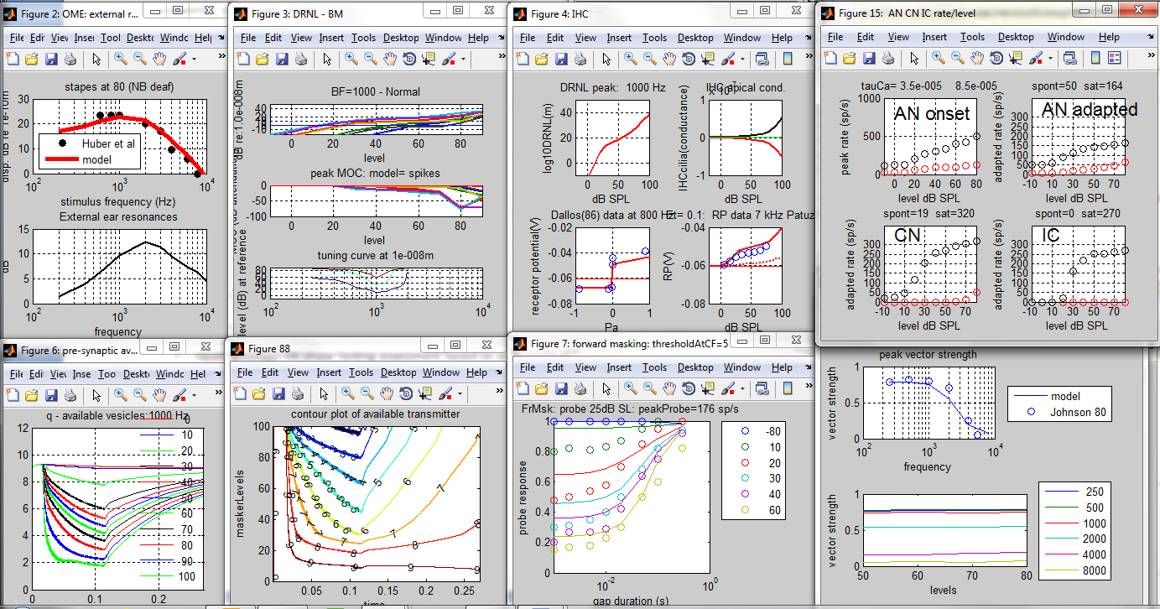
Figure 6

testPhysiologyProb(1000, 'Normal', paramChanges)
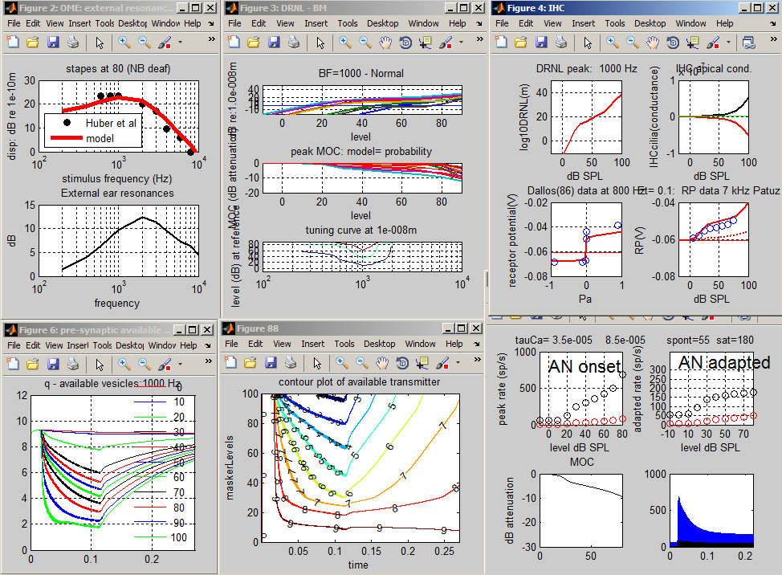
Figure 7

Warnings
The current version makes no checks on model parameters in terms of how sensible they are. However, all parameters are in international units and must be physiologically plausible.
The program ships with a set of model parameters in the parameter file ‘MAPparamsNormal’. These parameters are simply the values that the author has found to be most satisfactory. They are not perfect. If you wish to use them for research purposes, you should ask the author (rmeddis@essex.ac.uk) for the latest versions and any documentary support. This is cutting-edge stuff and, no, it is not yet published.

multiThreshold
The purpose of auditory model is ultimately to model human hearing to the extent that the two cannot be distinguished (a kind of Turing test). A step in this direction is to administer the same tests to the model that might be applied to the human listener. MultiThreshold is a software controller of a range of psychophysical tests that have been designed to be suitable for testing both humans and the MAP model. Three tests are of particular interest; 1) absolute threshold, 2) psychophysical tuning curves and 3) threshold masking curves. These are tests of sensitivity, frequency selectivity and compression respectively.
Here is an example of a hearing profile produced using multithreshold harnessed to the MAP model.
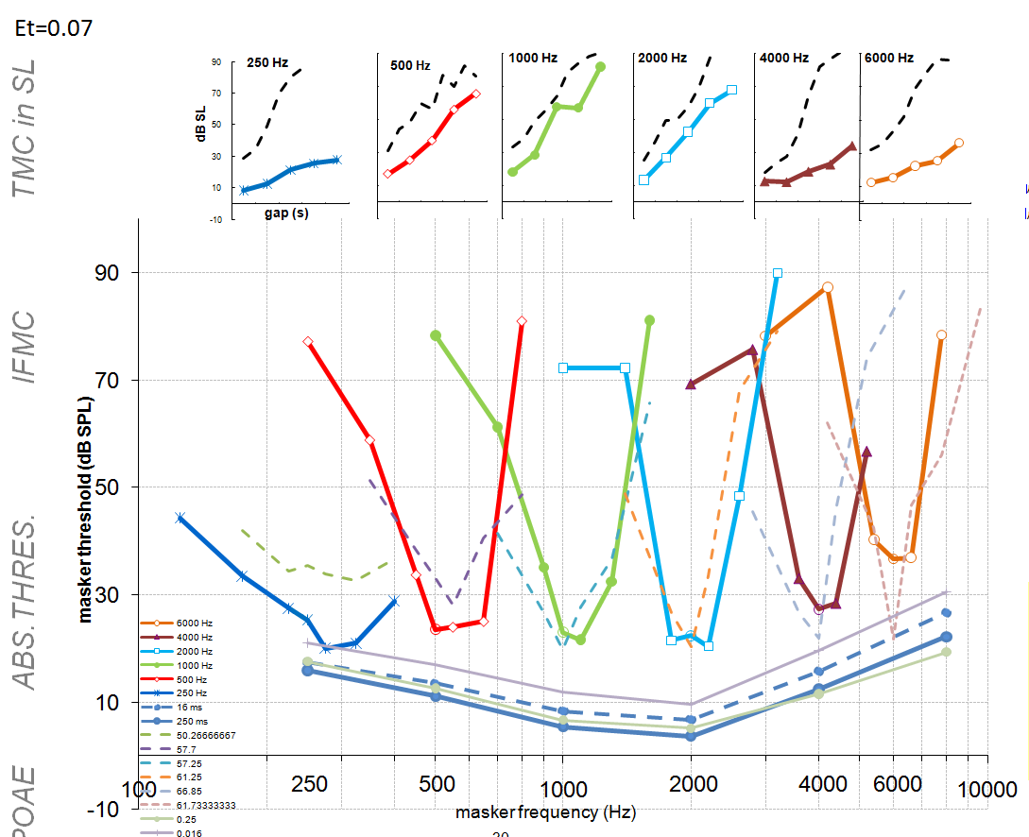
Figure 8

This profile is similar to a profile for a normal human listener. Here are two more profiles designed to simulated impaired hearing. The faint and dashed lines are data collected from a young man with good hearing
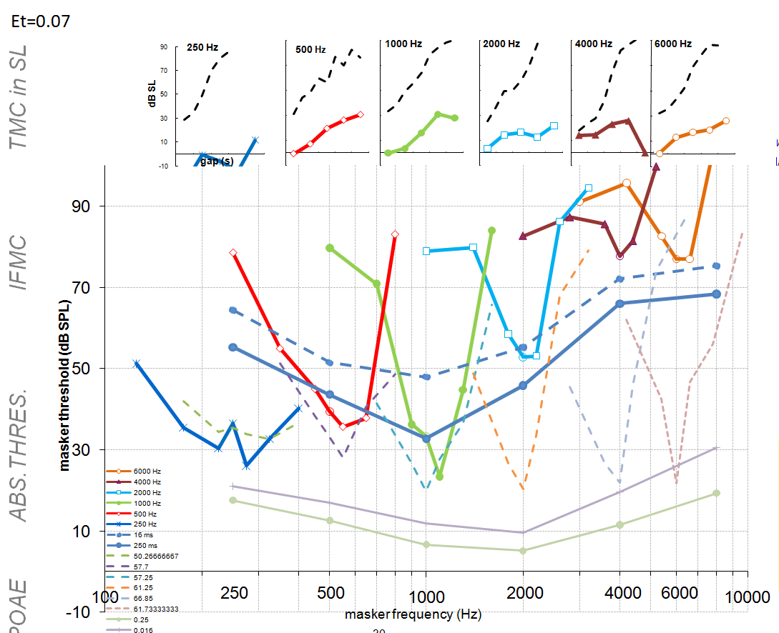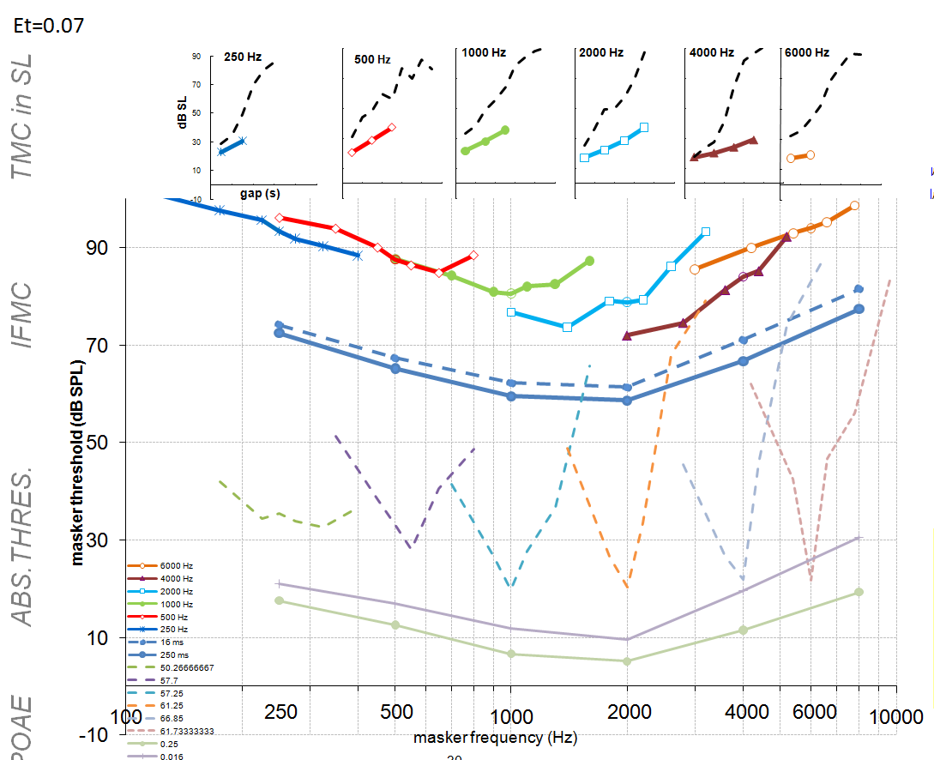
Figure 9

In the left panel, the impairment is induced by reducing the endocochlear potential from 100 mV to 70 mV. In the right hand panel, the impairment is created by disabling the contribution of all hair cells. The faint lines are normal human.
Multithreshold_MT will generate a profile for you.
- Navigate to the multithreshold 1.64 folder in the MAP 1_14 folder
- Run expGUI_MT.m to display the GUI. 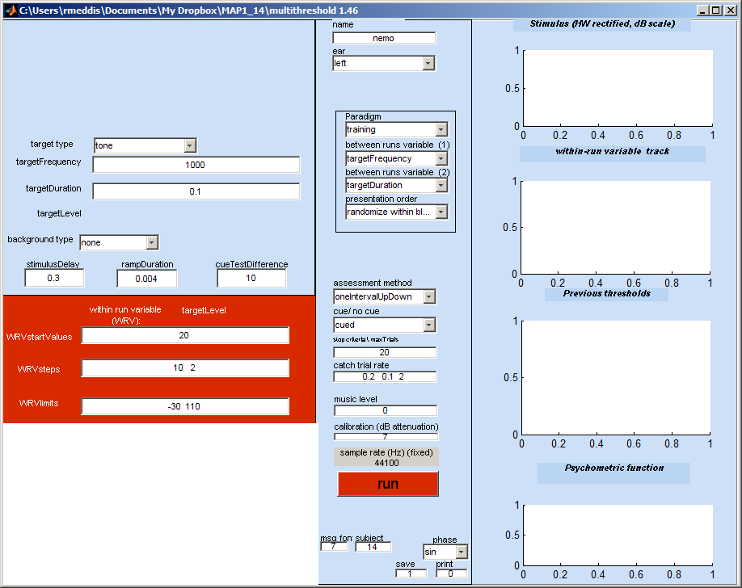
Figure 10
- From the ear menu (middle panel 2nd from top), select ‘MAPmodelSingleChannel’
- From the paradigm menu (below the ‘ear’ menu) , select ‘profile’
- Hit the run button and sit back. A profile should be generated after considerable computation looking like this:
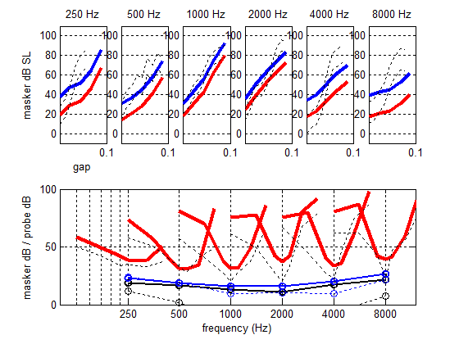
Figure 11
Notes:
- The faint dashed lines on the figure are data collected from a young male listener with normal hearing (CMa). The thicker lines are the model results. The model is tested in the same way as the listener; the stimulus is presented and the model has to say ‘yes’ or ‘no’ according to whether or not the probe was ‘heard’ by the model.
- The thin blue lines in the bottom panel with circles are absolute thresholds for 250 ms and 16-ms tones.
- Frequency selectivity: the V-shaped curves are iso-forward masking contours (IFMCs). A short (16-ms) probe tone is presented at 10 dB SL and is preceded by a 108-ms pure-tone masker. The listener is asked to say whether or not he hears the probe tone. The level of the masker is adjusted until the probe is heard on 50% of presentations. Measurements are made for different masker frequencies (over an octave range covering the probe tone). The IFMC is a record of these masker levels. IFMCs are measured for probes at 250, 500, 1000, 2000, 4000, 8000 Hz and for masker frequencies at 0.5, 0.7, 0.9, 1, 1.1, 1.3 and 1.6 times probe frequency.
- Compression: the top panel records 108-ms pure-tone masker levels required to mask a brief, 16-ms probe tone presented at 10 dB SL on 50 % of presentations. The probe and the masker always have the same frequency but the gap between the masker and the probe is systematically varied between 10 and 90 ms. This is called a temporal masking curve (TMC). The masker levels in dB SL are given as the lower of the two lines. The upper line is the same data presented as dB SPL. The steepness of the line is affected by more than one physiological factor. However, if we assume that the recovery from forward masking occurs at a fixed rate, we can infer that the steepness of the line reflects, at least in part, compression of the response to the masker; most likely either at the basilar membrane or the inner hair cell.
- Diagnosis: in the figure above, the model absolute thresholds are high compared to the human data. The IFMCs are a reasonable fit and the TMCs are a good fit at low frequencies but not at high frequencies. The aim, of course, is to find a set of parameters that offers a good fit to all of the data.

Changing parameters
- The user can seek a better fit by changing the model parameters. The parameters can be found in the parameter file in the folder called ‘parameterStore’. On this occasion the file MAPparamsNormal contains the parameters. This file is specified on the GUI as ‘Normal’ in the edit box called name at the top of the GUI. One way to change the parameters is by altering the parameters in this file and repeating the run.
- If only a small number of parameters need be changed, this can be done on the GUI in the yellow box at the bottom left. This normally contains the empty cell array command paramChanges= {' '}; This can be edited by adding a string inside the quotes, e.g. paramChanges= {' DRNLParams.a=0 '}; Before the run begins, this change is automatically made to the parameters that have been read from the file.
- At the end of each run, a complete list of parameters and their values is printed in the command window. These can be copied and pasted into the GUI (but remember to ad the semi-colon before the final quote.
- If more than one change is required this can be achieved by putting both changes inside their own quotes but separated by a comma (both inside the curly brackets, e.g. paramChanges= {' DRNLParams.a=0 ', ‘DRNLParams.g=500’}; . Line breaks at not currently allowed in this process.
- When paramChanges= {' DRNLParams.a=0 '}; is requested we get a profile that looks like this. This parameter change effectively disables the OHC contribution to the BM response.
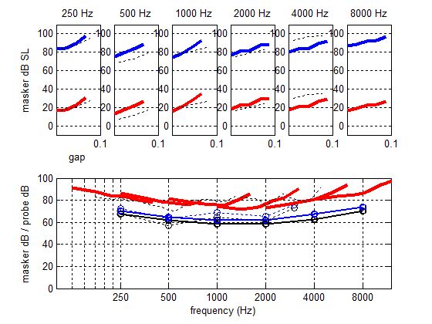
Figure 12

